

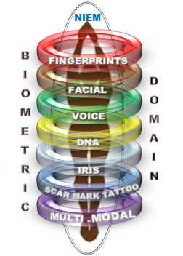

**NIEM Collaboration Support –** **“How To” Guide for Creating NIEM Biometric Exchange**

5 April 2018

**Draft**

Submitted by:

Integral Consulting Services, Inc.

2101 Gaither Road, Suite 410

Rockville, MD 20850

Contract Number: GS00Q14OADS145

Delivery Order Number: HSHQDC-17-F-00189

**Approval**

**DHS OBIM Signatures**

**Approved by: _____________________________________________________**

**Mr. John Boyd Date**

**NIEM Biometrics Domain Chair**

**Identity Technology Division**

**Office of Biometric Identity Management**

**Approved by: _____________________________________________________**

**Mr. Thomas Freed Date**

**Information Technology Specialist**

**Identity Technology Division**

**Office of Biometric Identity Management**

**Record of Changes**

| No. | Date | Reference: Page, Table, Figure, Paragraph | A = Add. M = Mod. D = Del. | Change Description |
| --- | --- | --- | --- | --- |
| 1 | 4-5-2018 | All | A | Initial Version |
| 2 | 1-23-2019 | P ii | M | Updated Thomas Freed Title |

**Table of Contents**

1 Introduction 5

1.1 Overview 5

1.2 Scope 5

1.3 Background 5

1.4 Intended Audience 6

2 NIEM Overview 6

2.1 NIEM Data Model and Concepts 6

2.1.1 Types and Properties 7

2.1.2 Container Elements 8

2.1.3 Content Elements and Reference Elements 8

2.1.4 Associations 8

2.1.5 Roles 8

2.1.6 Code Lists 8

2.1.7 Augmentation 8

2.1.8 Metadata 8

2.1.9 External Adapter Types 8

2.2 Design Criteria for NIEM 8

2.3 Architecture of NIEM Data Model 9

2.3.1 Relationship between Domain Components 11

3 Building NIEM Conformant Data Exchanges 12

3.1 NIEM Information Exchange Package Document (IEPD) Development Lifecycle 12

3.2 IEPD Artifacts 14

3.3 IEPD Metadata 14

4 Data Model Conformance Guidelines 17

5 NIEM Tools 18

6 NIEM Resources 20

6.1 NISS Help Desk and Knowledge Base 21

6.2 NIEM Website 21

6.3 IEPD Clearing House 22

6.4 NIEM Training 22

7 References 22

Appendix A Glossary of Abbreviations, Acronyms, and Initialisms 23

**List of Figures and Tables**

Figure 1: NIEM Core and Domains 10

Figure 2: NIEM Data Model Components 11

Figure 3: IEPD Life Cycle 13

Figure 5: IEPD Artifacts 14

Table 1: Comparison of Terminology across NIEM Data Model and UML 8

Table 2: IEPD Metadata 17

# Introduction

## Overview

The Office of Biometric Identity Management (OBIM) within the National Protection and Programs Directorate (NPPD) of the Department of Homeland Security (DHS) supports the DHS mission to protect our nation by providing biometric identification services to federal, state, and local government decision makers to help them accurately identify the people they encounter, and to determine whether those people pose a risk to the United States.

As the lead DHS entity for biometric identity management services, OBIM provides DHS and its mission partners with enterprise-level biometric identity information. OBIM operates and maintains the Automated Biometric Identification System (IDENT) and provides identity services expertise as a service provider for customers across DHS, at other federal agencies, in state and local law enforcement, and globally. IDENT, the OBIM Automated Biometric Identification System is one of the world’s largest biometric identity repositories, holding biometric identity information about more than 220 million individuals. OBIM also focuses on improving biometric sharing in support of national security and public safety. By matching, storing, sharing, and analyzing biometric data, OBIM provides partners on the front lines of homeland security with rapid, accurate, and secure identification.

As OBIM continues to expand its biometric identity management services to include additional biometric modalities and stakeholders, maintaining active participation in standards development organizations, such as the National Information Exchange Model (NIEM), National Institute of Standards and Technology (NIST), the International Committee for Information Technology Standards, International Organization for Standardization, and International Civil Aviation Organization, will be important to the OBIM enterprise target long-term service-oriented architecture.

This “How To” guide documents the process for creating NIEM exchanges necessary for Biometric Domain development and maintenance. It also identifies a variety of support processes including IEPD development that are relevant to successful interoperability of NIEM exchanges.

## Scope

The NIEM “How To” guide provides details about how to develop information exchanges utilizing the NIEM model. It provides a detailed description of the rationale behind NIEM, an architectural overview, and technical concepts derived from NIEM Program Management Organization (PMO) documentation. This document describes the methodology for defining the business requirements of the information exchange, as well as creating an Information Exchange Package Documentation (IEPD) which fully specifies the exchange in conformance with NIEM guidelines. The guide also includes information about the tools necessary for NIEM development, resources for NIEM education and peer assistance, emerging technologies, and how they relate to NIEM.

## Background

NIEM is represented as a set of Extensible Markup Language (XML) Schema documents which define data components and result in information exchange package documentation (IEPD) which use these components to define information exchange packages (IEP) shared in the NIEM community. NIEM’s goal is to define common data components in IEPs to ensure they remain highly reusable as processes and comprehension are improved, while reducing information exchange errors.

The NIEM model content is partitioned into specialized Domains representing data requirements for a community of interest (COI) or line of business; the NIEM core is common to all Domains. The data components comprising NIEM are published as a set of NIEM releases. Each release is composed of a set of schema documents which include a NIEM core schema document, special schema documents (structures.xsd and appinfo.xsd), multiple Domain schema documents, and code table schema documents. Also, each Domain has a body of Domain representatives responsible for maintaining the code table schema document contents and timelines for updates and publication.

Developing and implementing NIEM-based exchanges allows agencies to leverage existing investments in information systems by building the bridges to connect them. NIEM standards enable different information systems to share and exchange information, irrespective of technologies in use by those information systems. Creating and adopting NIEM standards enables local, state, tribal, and federal organizations to obtain significant cost benefits, rather than building proprietary, single-use software from scratch.

## Intended Audience

The audience for this document comprises engineers and developers who intend to use the NIEM standard to support interagency information sharing, the Biometric Domain COIs, stakeholders, and governance groups, as well as the NIEM Program Management Office for reference purposes.

# NIEM Overview

NIEM is a foundation to build information exchanges. NIEM provides rules and methodologies around the use of the model as well as a standardized Information Exchange Development Lifecycle which can be reused by communities of interest (COI). NIEM also includes governance, training, tools, technical assistance, and an engaged community to support users and organizations adopting NIEM.

The NIEM Biometric domain is part of a coordinated global effort to maintain and refine operations focused on security, intelligence, law enforcement, international trade, travel and immigration by means of identity management and assurance.

The Biometric domain supports information sharing and promotes interoperability between mission-based organizations engaged in activities such as homeland security, national defense, border management, immigration benefits and global law enforcement through the joint development and alignment of (Extensible Markup Language) XML Biometric Standards. The Biometric domain updates its members and stakeholders on domain highlights and offers opportunities for sharing new issues and ideas. Through its high level of engagement, the Biometric domain captures and promotes operational best practices and participates in the NIEM Business Architecture Committee (NBAC) and associated working groups.

## NIEM Data Model and Concepts

NIEM is a standardized data model and a reference vocabulary implemented in the form of XML Schema. The NIEM data model states exactly and explicitly the meaning of a given concept or relationship. The NIEM data model and dictionary are combined into one component repository which allows the consistent generation of several schemas which can be consumed by the sharing community as listed below:

* The NIEM schema
* Numerous external code table schemas
* A NIEM documentation spreadsheet

The purpose of NIEM is to provide a standard but extensible format for use in the exchange of information between information systems. NIEM employs several concepts to address common concerns in the design of data models which represent information being exchanged between software systems. Each of the below concepts comes with a prescribed mechanism to follow when designing NIEM-conformant XML Data Model schema types and using elements of those types in XML instances.

### **Types and Properties**

These are representations of the physical and conceptual things being exchanged in NIEM. NIEM uses “Types” and “Properties” to express Object-Oriented Concepts in XML. The NIEM data model consists of “Types” (of things) that have “Properties” and that participate in “Relationships” with other “Types” (of things).

A Type is a description of a set of things that share the same properties, relationships, and semantics. For example, in NIEM, “PersonType” and “VehicleType” represent person and vehicle types. A Property is a named characteristic of a Type. For example, “PersonBirthDate” is a property of “PersonType.” Furthermore, the property is of a specific type itself. For example,” PersonBirthDate” is itself of Type “DateType.” A relationship may be modeled as either a Type or a Property.

A Relationship between persons and vehicles is represented by the Type “PersonVehicleAssociationType.” An object is an instance of a Type and is an abstraction of a specific physical or conceptual thing. In an object, the properties have values. For example, John Smith, a specific person, would be an object of Type “PersonType” with the Property “PersonBirthDate.” Also, for John Smith, the Property “PersonBirthDate” may have a value of “1970-01-01.”

An object may have a unique ID within an XML instance, but it is not required to have a globally unique identifier. The presence of specific objects in an exchange makes the assertions that objects exist, have properties, and participate in relationships.

The NIEM data model is explicit, not implicit. If the data says a person’s name is John Smith, it is not implying that he does not have other names or that John Smith is his legal name or that he is different from a person known as Bob Jones. The only assertion being made is that one of the names by which this person is known is John Smith. As shown in Table 1, Types, Properties, and Objects in the NIEM data model have equivalent concepts in XML Schema and Unified Modeling Language (UML). NIEM Data Model XML Schema/XML Instance UML Type e.g., “PersonType” Complex Type or Simple Type e.g., nc:PersonType Class Property e.g., “PersonBirthDate” of type “DateType” Element or Attribute e.g., nc:PersonBirthDate of type nc:DateType Attribute Object e.g., “Person” Element or Attribute e.g., nc:Person Instance/Object.

As shown in **Table 1: Comparison of Terminology across NIEM Data Model and UML**, types, properties, and objects in the NIEM data model have equivalent concepts in XML Schema and Unified Modeling Language (UML).

|  |  |  |  |
| --- | --- | --- | --- |
| No. | NIEM Data Model | XML Schema/XML Instance | UML |
| **1.** | **Type**  e.g., “PersonType” | Complex Type or Simple Type  e.g., nc:PersonType | Class |
| **2**. | **Property**  e.g., “PersonBirthDate” of type “DateType” | Element or Attribute  e.g., nc:PersonBirthDate of type nc:DateType | Attribute |
| **3**. | **Object**  e.g., “Person” | Element or Attribute  e.g., nc:Person | Instance / Object |

Table 1: Comparison of Terminology across NIEM Data Model and UML

### **Container Elements**

These are elements of homogenous nature and are grouped under a Container.

### **Content Elements and Reference Elements**

These are two semantically equivalent ways to represent the properties of a type.

### **Associations**

These represent relationships which a type (e.g., “PersonType”) has with other types (e.g., “VehicleType,” “ActivityType”) which do not create duplicate copies of the type in question (“PersonType”).

### **Roles**

The representation of different roles (e.g., “Victim Type,” “WitnessType”) which a type (e.g., “PersonType”) plays in its relationships with other types (e.g., “Incident Type,” “CaseType”) which do not create multiple, and possibly conflicting, specializations of the type in question (“PersonType”).

### **Code Lists**

These define generic representations of enumerated code values of a type.

### **Augmentation**

This define reusable bundle of properties (e.g., “PersonAugmentationType” containing properties “DriverLicense,” “PersonFootPrint,” etc.) for the purpose of augmenting the definition of an existing type (e.g., “PersonType”) which does not create multiple, and possibly conflicting, specializations of the type in question (“PersonType”).

### **Metadata**

This helps representation of metadata of types in a flexible and extensible manner.

### **External Adapter Types**

This provides ability to use non-NIEM types in a NIEM-conformant schema.

## Design Criteria for NIEM

The primary goal of NIEM is to develop a common set of reusable and extensible XML data components which can be utilized in transactions and messages to support interoperability between systems. The schema created shall follow the design rules specified within the NIEM Naming and Design Rules (NDR). All required artifacts in an IEPD and its required file structure should follow the Model Package Description (MPD). The following design criteria is suggested in the development of NIEM:

* NIEM should be developed from requirements artifacts, i.e. functional requirements, reference documents, use cases, and business-context components.
* An object-oriented data model, named types, and extensions are best suited towards the goals of interagency information exchange.
* The composition of the data dictionary should be over-inclusive and optional to allow users to pick and choose appropriate building blocks for their data exchanges.
* NIEM element and attribute tag names should be based on relevant international standards for electronic data exchange, especially ISO/IEC 11179- 5:1995—Specification and Standardization of Data Elements, as discussed in the NIEM Naming and Design Rules (NDR). Additional source standards include, but are not limited to:
* W3C XML Schema Specification and Resource Description Framework (RDF) Schema Specification
* The Federal Chief Information Officer (CIO) Council Draft Federal XML Schema Developer’s Guide
* United Nations Centre for Trade Facilitation and Electronic Business (UN/CEFACT) Electronic Business using eXtensible Markup Language (ebXML) Core Components Technical Specification 2.01
* Dublin Core Metadata for Documents
* U.S. Department of Defense 5015.02-Standard Design Criteria Standard for Electronic Record Management(E-RMS) Applications
* The OASIS XML Common Biometrics Format
* The ASC X12 Reference Model for XML Design
* NIEM continues to evolve, so the data model must facilitate change and extension as required.
* Extension methods should comply with NIEM Naming and Design Rules (NDR) to minimize the impact on earlier versions of schema and corresponding development effort by practitioners and developers.
* NIEM should provide migration paths for evolution to new technologies, such as Resource Description Framework (RDF) and Web Ontology Language (OWL).
* NIEM should provide a mechanism through which standards for information exchange can be defined with a higher degree of granularity.

## Architecture of NIEM Data Model

The NIEM data model provides the reference vocabulary for consistent and reusable intra- and inter-domain information exchanges. The structure and meaning of NIEM data is defined by the model and dictionary and it is represented as an XML schema, thereby providing a common framework for information exchange.

The NIEM Data model is technology agnostic to stay abreast of technological advancements and continue to aid in the development of semantically consistent interoperable information sharing. Future versions of NIEM are anticipated to migrate to new and evolving forms as technology advances.

The NIEM Data model relates to and supports the Federal Enterprise Architecture (FEA) Business Reference Model (BRM) and Data Reference Model (DRM). The BRM drives the business requirement‐based taxonomy and domain identification, and NIEM, which focuses on message content, is an implementation of the DRM information sharing layer.

The fundamental building block of NIEM is a data component. Data components are the basic business data items which describe common concepts used in general business activities.

The NIEM Data Model architecture consists of two sets of vocabularies, Core and the individual NIEM domains. NIEM Core includes Universal (U) and Common (C) components as illustrated in the below **Figure 1: NIEM Core and Domains**. The identities for U and C components in NIEM Core are maintained with metadata.

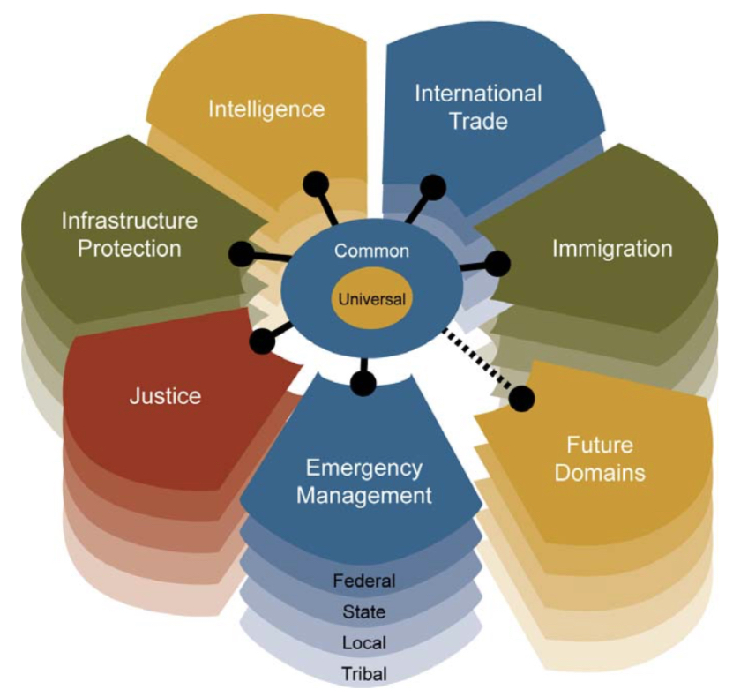

Figure 1: NIEM Core and Domains

The NIEM Data Model Schema contains many XML data types and properties. It is recommended to avoid creating new data types and properties when similar ones exist within the data model. Therefore, it is necessary to understand the structure of the NIEM data model and navigate through the data model to select the subset of schema which can be reused. The data elements and types can be classified into several broad categories:

**NIEM Core components:** These are basic NIEM objects and contain core entities like Activity, Person, Document, etc. In addition, the NIEM Core components also describe more complex entities such as drugs, vehicles, locations which are useful across multiple domains.

**Domains:** These represent specialized information models which represent information in verticals such as biometrics, emergency management, justice, immigration, etc.

**Appinfo:** This schema provides support for high-level data model concepts and additional syntax to support the NIEM conceptual model and validation of NIEM-conformant instances.

**Structures:** These elements enable consistent linking and description of information in NIEM. These elements are also used to connect metadata to objects.

**Standard Code Lists:** These data elements and types are external standards outside of NIEM, but they are extremely useful in ensuring the information is described in a consistent manner.

In addition to the XML objects mentioned above, NIEM also provides a mechanism to annotate individual data elements with metadata. When possible, the metadata can be created as an entire XML object and be associated with the appropriate piece of information whose characteristics are being described. This is achieved by using the XML objects:MetadataType. If this isn’t possible, individual elements of data can be annotated and in those cases, it is preferable to use XML attributes provided by NIEM.

### Relationship between Domain Components

The data elements and types defined in each of the groups are interrelated in a specific manner. For instance, elements in the Structures depend only on basic XML constructs. Elements in NIEM Core depend only on each other and the elements in structures. As such, elements in the Structure groups can be considered primary while the data elements in the NIEM Core and the various domains represent increased specialization of information. Components in the domains depend on components in the NIEM Core, Structures, and, in some cases, on each other. A NIEM developer could use or extend the elements from all of the namespaces for a developed reference schema which reflects a particular information exchange. These relationships are illustrated in the below **Figure 2:** **NIEM Data Model Components.** The components in the domains are represented as dependent on the components in the NIEM Core. Components in the external code sets are independent of the components in NIEM. Components in reference schemas can utilize components in the domains and in NIEM Core. External code sets are also available to the applications for consumption.

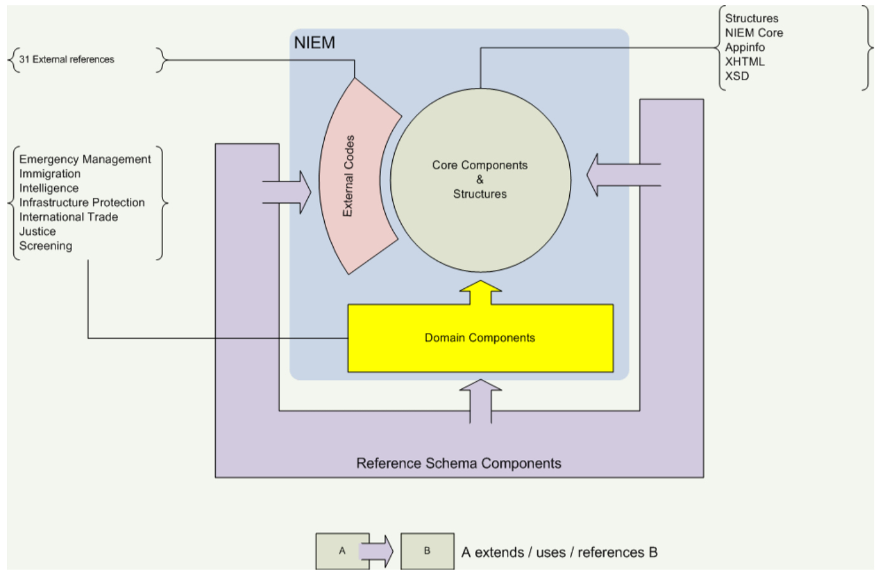

Figure 2: NIEM Data Model Components

# Building NIEM Conformant Data Exchanges

The goal of NIEM conformance is for the sender and receiver of information to share a common and unambiguous understanding of the meaning of shared information. Conformance to NIEM ensures the NIEM components are well-understood and carry the same consistent meaning across various COIs. This enables a level of interoperability to occur which would be unachievable with the proliferation of custom schemas and dictionaries.

In order to begin exchanging information, partners will need to develop data exchanges, also known as Information Exchange Packages (IEPs), which are then documented as Information Exchange Package Documents (IEPDs). An IEPD is a complete definition of an IEP. It is a compilation of documentation which can be understood by the producer of the information exchange and the receiver. Generally, it is composed of schemas for data exchange and documentation for understanding the business context and usage.

The subsequent sections describe the process which can be used to guide the development of a NIEM IEP and associated IEPD. These processes serve as a guide or template for the development of IEPs and IEPDs and can be customized as necessary to suit the needs of domain. It provides a useful starting point in project planning and can help to set high-level expectations regarding milestones, resources, and timelines. It is necessary to follow certain file structure and design rules for NIEM Conformant Data Exchange and NIEM defines three types of conformance:

1. NIEM XML Schemas conform to the NIEM Naming and Design Rules (NDR).
2. NIEM Information Exchange Package Documentation (IEPD) conforms to the NIEM MPD Specification.
3. NIEM XML Instances conform by correctly validating to NIEM-conforming XML Schemas with additional conformance rules specified by the NIEM NDR.

## NIEM Information Exchange Package Document (IEPD) Development Lifecycle

A NIEM IEPD is a package which describes the construction and content of a NIEM information exchange. It contains all of the schemas necessary to represent and validate the data content of the exchange. It also contains supplemental artifacts, such as documentation, business rules, search, discovery metadata, and sample instances.

There are three core functions of IEPD development:

* To provide the business, functional, and technical details of the information exchange through predefined artifacts
* To create a core set of artifacts in a prescribed format and organizational structure to allow for consistency
* To design in order to share and reuse in the development of new information exchanges through publication in IEPD repositories

There may be one or more IEPDs for one information exchange. A NIEM-conformant IEPD must conform to the following formats:

* NIEM Naming and Design Rules (NDR) – The NDR specifies rules to standardize schema development and provides a blueprint for NIEM conformance. It also provides rules for NIEM reference schemas, NIEM Extensible Markup Language (XML) elements, and other NIEM XML documents, including sample XML instances. NIEM, through NDR, aligns with the standards of the World Wide Web Consortium and the International Organization for Standardization.
* IEPD Specification – Similar to any systems development lifecycle, IEPD creation has a complete lifecycle, as shown in the below **Figure 3: IEPD Life Cycle**.

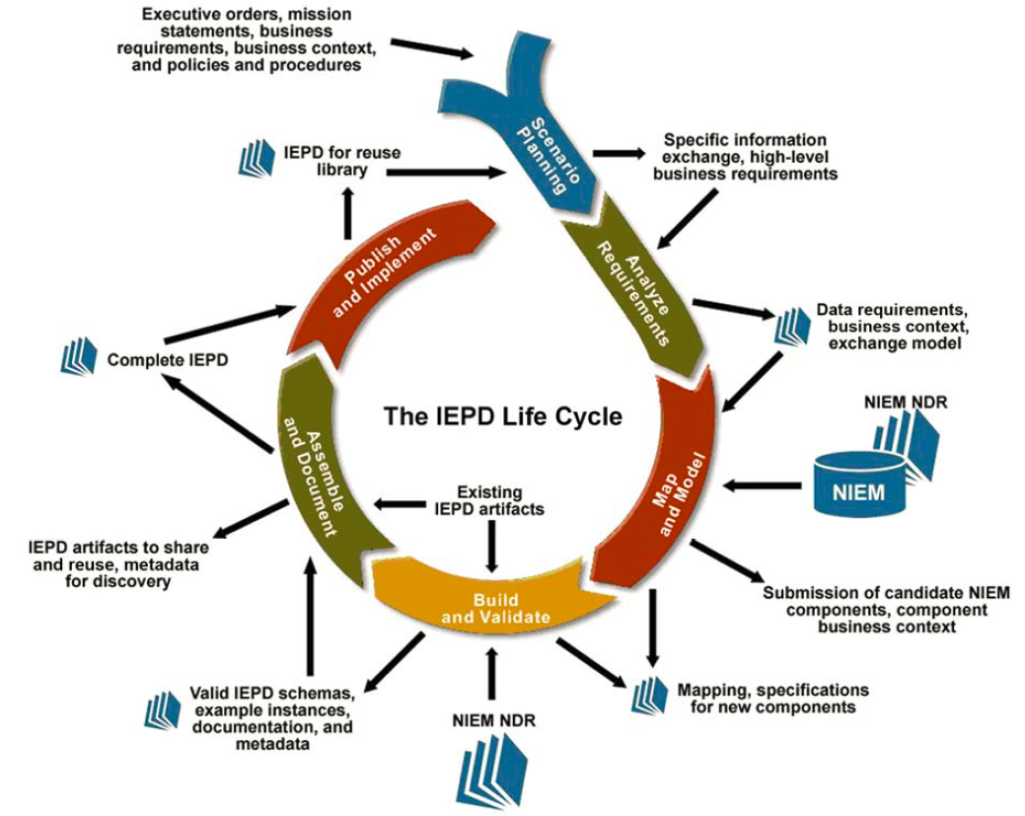

Figure 3: IEPD Life Cycle

The IEPD life cycle is the primary process from the practitioner’s perspective for development of the artifacts that define an information exchange specification. The IEPD life cycle below show a series of steps for building an IEPD.

* Scenario Planning: Planning of the project, establishing the process, and identifying exchange business requirements
* Analyze Requirements: Elaboration and documentation of the business context and data requirements
* Map and Model: Association of local objects with types and elements in NIEM, a process called mapping and exchange content model to NIEM
* Build and Validate: Creation of a set of exchange-specific, NIEM-conformant XML schemas which implement the data model created for exchange
* Assemble and Document: Preparation and packaging of all related files for this IEPD into a single self-contained, self-documented, portable archive file
* Publish and Implement: Publication of IEPD for search, discovery, and reuse

## IEPD Artifacts

IEPDs have a defined development methodology with a set of artifacts consisting of normative exchange specifications, examples, metadata, and documentation encapsulated by a catalog which describes each artifact. The entire package is archived as a single compressed file. When uncompressed, the catalog is a hyperlinked index into the IEPD and can be opened in a standard browser. The NIEM developer may use the catalog to overview the IEPD contents or to open each individual artifact, provided the appropriate software required to open a given artifact is installed. Best practices for most organizations include many of the artifacts shown in the below **Figure 5: IEPD Artifacts**.

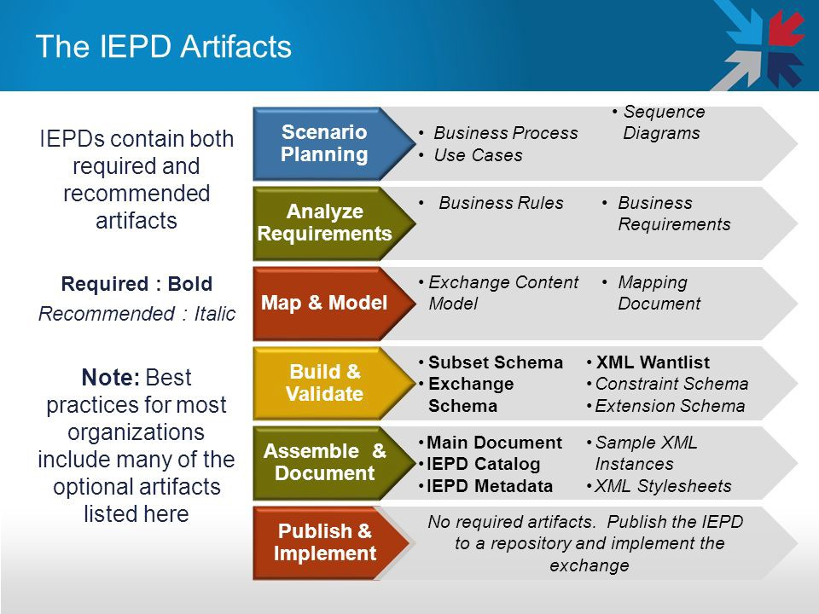.

Figure 5: IEPD Artifacts

## IEPD Metadata

The IEPD metadata artifact contains all metadata which the authoritative source wishes to register with an IEPD repository. This metadata should be specified by an XML schema so an instance for a given IEPD can be parsed, loaded into a registry, and used to search, discover, and harvest business context and metrics on IEPDs and their artifacts. The below list contains the Metadata item types which constitutes IEPD Metadata.

|  |  |  |  |
| --- | --- | --- | --- |
| Metadata Item Type | Metadata Item | Description | R - Required O - Optional |
| **Descriptive** | Uniform Resource Identifier (URI) Universal Identifier | Each IEPD version will have a distinct URI. | R |
| **Descriptive** | Name | Title of this IEPD (e.g., Amber Alert, Prosecutor Arrest Warrant). | R |
| **Descriptive** | Summary | Brief summary of this IEPD for short display purposes—maximum of 160 characters including spaces. | R |
| **Descriptive** | Security | Security label to indicate treatment or distribution of this IEPD; e.g., for official use only (FOUO), classified, sensitive but unclassified (SBU), public. The default is public, unless otherwise specified. | R |
| **Descriptive** | Description | Narrative description of this IEPD may contain as much detail as the NIEM developer determines is useful to those with a potential interest in this IEPD. | O |
| **Descriptive** | Website | URL of the website where this IEPD and related artifacts (e.g., XML O schema, documentation, mapping spreadsheets) are posted. | O |
| **Change log data** | Creation Date | Project start date in YYYYMM format indicating when planning or work on this IEPD started. Do NOT confuse with date on which this IEPD is submitted. | R |
| **Change log data** | Version | Version of this IEPD. | R |
| **Change log data** | NIEM version | NIEM version used for this IEPD. | R |
| **Change log data** | Last revision date | Year and month in YYYYMM format this IEPD information was last revised. Do NOT confuse with the date on which the IEPD itself was last revised, generating a new IEPD version. | O |
| **Change log data** | Next revision date | Year and month in YYYYMM format this IEPD information is expected to be revised. | O |
| **Status** | Maturity | State of development: Entry level - under development with minimum documentation; Complete - being tested and in limited use with draft documentation; In production - fully documented and endorsed for use in official exchanges. | R |
| **Status** | Status | Description or additional information related to current state of this IEPD. | O |
| **Status** | Schedule | Information about the development schedule for this IEPD (e.g., “Development started YYYYMM; draft planned YYYYMM; completion planned YYYYMM”). | O |
| **Status** | Endorsements | Names and acronyms of professional or governmental organizations which support this IEPD as official business information exchange package. | O |
| **Status** | Sponsors | Name of organization(s) which sponsored, contributed, or participated in the development of the IEPD. | O |
| **Navigation** | Lineage | IEPDs from or with which this IEPD was derived or built, identified by URI. This is not normal version control. |  |
| **Navigation** | Relationships | URIs of other IEPDs and their relationship to this IEPD; should not duplicate other attributes such as Lineage, line(s) of business (LoB), Organization, etc. | O |
| **Navigation** | Keywords | Search terms which would not otherwise be in other metadata attributes (e.g., Georgia's Levi's Call for an Amber Alert). | O |
| **Business Context** | Domains | Primary domains or LoB which this IEPD covers. | R |
| **Business Context** | Purpose | A short description of the business reason for using this IEPD which may include a brief statement of scope. | R |
| **Business Context** | Message exchange patterns | Category of transaction for which this IEPD is designed and used (e.g., query/response, message, publish/subscribe, document, etc.) | O |
| **Business Context** | Communications environment | Description of the primary communications environment(s) for which this IEPD was designed (e.g., wireless, satellite, broadband, T1). | O |
| **Business Context** | Exchange partner categories | Types of organizations which would use this IEPD. | O |
| **Business Context** | Exchange partners | Names of the organizations which are using this IEPD. | O |
| **Business Context** | Process | Business process during which this IEPD is exchanged. | O |
| **Business Context** | Triggering event | Event(s) which cause this IEPD to be exchanged. | O |
| **Business Context** | Conditions | Condition(s) under which this IEPD is exchanged. | O |
| **Authoritative Source** | organization name | Organization responsible for owning and maintaining the IEPD or Information Exchange related artifacts and metadata; includes both full name and acronym, as appropriate, to enhance discovery. | R |

Table 2: IEPD Metadata

# Data Model Conformance Guidelines

NIEM is a data model and reference dictionary which is not a rigid standard and it does not need to be used in its entirety. NIEM was designed as a core set of building blocks which are used as a consistent baseline for creating exchange documents. However, there are several informal conformance requirements which the NIEM schema needs to adhere to enable interoperability.

NIEM does not define information exchange implementation conformance. In general, an implementation which deploys NIEM-conformant instance XML documents on a transmission medium is considered a NIEM information exchange. However, an implementation may also apply encryption, compression, Efficient XML Interchange (EXI) encoding (W3-EXI), or other security and/or efficiency techniques to the NIEM instance XML documents as required and this is still considered a NIEM information exchange.

NIEM is considered a payload layer, and as such, NIEM-conformant instance XML may be contained within standard envelopes such as SOAP, Law Enforcement Information Sharing Program (LEISP) Exchange Specification (LEXS), etc. or other XML-based standards. When describing a NIEM schema implementation, it should be as descriptive as necessary to convey a clear understanding of how the NIEM exchange can be used.

Reference schema document sets (i.e., NIEM releases, domain updates, and core updates) are subject to rigorous quality and conformance testing to ensure they are NIEM-conformant. However, IEPDs are not under the NIEM PMO control and are not subject to a formal certification process. Therefore, it is important for NIEM users and developers to understand and make a concerted effort to ensure the Information Exchange Package Documentation (IEPD) they produce conforms to the (NIEM-MPD) Specification.

These conformance rules serve as guidelines for any agency utilizing NIEM to implement its information sharing exchanges:

* Schema instances must validate against the set of NIEM reference schemas. Schemas conformant to NIEM must import and reference the NIEM Schema namespace they need to use (e.g., NIEM Core, Justice, etc.) or a conformant NIEM Schema subset. If an instance validates against a correct subset of the NIEM reference schemas, it will validate against the NIEM reference schemas.
* If the appropriate component including type, element, and attribute required for an IEPD exists in NIEM, it is recommended to use those components instead of creating a duplicate component which already exists.
* Be semantically consistent by using NIEM components in accordance with their definitions. It is suggested not to use a NIEM element to encapsulate data other than what its definition describes.
* Follow the Information Exchange Package Documentation (IEPD) Development Lifecycle as described in the IEPD Requirements and define all required artifacts at each step as necessary.
* Adhere to the NIEM Naming and Design Rules (NDR) to ensure correct and consistent schema development.

In general, the three most basic NIEM conformance targets are:

1. **Conformant instance XML document** - An XML document which is an instance of a conformant schema document set and must conform to all applicable rules in the NIEM Naming and Design Rules (NIEM-NDR).
2. **Conformant schema document set** - A collection of XML Schema documents which together are capable of validating a conformant instance XML document. A conformant schema document set must conform to all applicable rules in the NIEM NDR.
3. **Conformant Model Package Description** (MPD) - A zip archive which contains a conformant schema document set adhering to the rules specified in the NIEM Model Package Description Specification (NIEM-MPD) and applying to its MPD class. There are five NIEM MPD classes: release, domain update, core update, Information Exchange Package Documentation (IEPD), and Enterprise Information Exchange Model (EIEM).

# NIEM Tools

NIEM tools are utilized at various stages of the IEPD development lifecycle when developing NIEM exchange specifications. Below is a list of tools in the order they can be used during the development of a NIEM exchange which mirrors the IEPD development lifecycle. A directory listing of the below tools can be found at <https://www.niem.gov/tools-catalog>.

**Universal Modeling Language (UML) Tools:** UML tools are used to provide an efficient way of modeling data object classes, their attributes and dependencies. The first commercially available tool completely in line with the NIEM-UML standard is Magic Draw - Cameo NIEM Plugin enabling full information exchange life-cycle development. Sparks Systems Enterprise Architect is another UML Modeling tool. Employing this tool, users build their IEPDs to generate the subset schemas from the model to produce exchange files, static artifacts, metadata and catalog files.

**NIEM Data Model Browser:** NIEM Data Model Browser enables the user to graphically explore the NIEM model and relationships between data classes and explore data elements.

**NIEM Wayfarer:** NIEM Wayfarer is a non-NIEM.gov application that is funded by the National Center for State Courts. It was developed as an alternative to the SSGT for exploring the NIEM model, its corresponding elements, attributes, and data types, and the relationships between them. Visual NIEM displays NIEM elements in a graphical format as a large wheel with NIEM elements in it. NIEM users search the elements needed and drill into details which can be included in their subset schema for development.

**Subset Schema Generation Tool (SSGT):** SSGT has a strong set of advanced search features which helps map exchange data elements to NIEM and create new exchanges. It provides a text-based display of the search results and enables navigation through the properties, types, and facets, and their relationships. Once the user selects the properties and the type required for a data exchange and generates a schema subset of the full NIEM schema set, all dependencies are automatically added to ensure the resulting schema subset is valid. The user will have ability to save or reload requirements in a wantlist file.

**Component Mapping Template (CMT):** CMT helps facilitate the mapping of the exchange elements to the equivalent NIEM terms and identifies mapping gaps which form the basis of the extension schema.

**Code List Schema Tool:** Code List Schema Tool is used to create a NIEM- conformant schema enabling an application to validate XML data against a list of restricted values. It generates a standard NIEM conformant code list schema from an Excel or CSV (Comma Separated Value) file. The user enters the namespace and version parameters and uploads an Excel spreadsheet file containing code type names and corresponding code values and definitions. Then the user downloads the NIEM conformant schema. A single Excel file can be used to generate multiple code types and associated values in one schema. For separate schemas, separate Excel files should be utilized. A simple input template.xls and sample output file template.xsd format are available to examine or clone.

**Migration Assistance Tool (MAT):** NIEM Migration Assistance Tool helps convert GJXDM 3.0.x or NIEM 1.0 Wantlist to a newer NIEM Versions Wantlist. It outputs the NIEM Wantlist, NIEM subset, and migration report. The migration report contains actions taken and choices made during the wantlist migration including issues which cannot be resolved automatically, and statistics indicating the degree of migration resolution.

**Movement:** Movement is an open source tool which offers a better way to search model content and simpler way to use it. The tool provides users an intuitive way to pick and choose NIEM model content and automatically export conventional JSON Schemas for their simple exchanges.

**NIEM JAVA Biding Tool:** An open source Java tool which uses Maven and Java Architecture for XML Binding (JAXB) to implement NIEM based exchanges. The functions within the tool can generate consistent bindings to Java objects for NIEM schema subsets and extension schema documents. It contains example Representational State Transfer (REST) services with XML.

**Conformance Testing Assistant (ConTesA):** ConTesA assists developers by automatically identifying potential locations of non-conformance within IEPD artifacts using the NIEM NDR and IEPD specifications.

**Content Assembly Mechanism (CAM):** The CAM editor is an open source toolkit for building and deploying information exchanges and Open Data APIs using NIEM and XML or JSON with Structured Query Language (SQL). The CAM toolkit provides an intuitive approach using a What You See Is What You Get (WYSIWYG) visual structure editor to dramatically simplify the process of developing and managing XML business information exchanges and schema. This gives developers control, insight and analysis for consistent, interoperable and reliable exchanges. The CAM toolkit automates generation of supporting artifacts such as NIEM IEPD business documentation, cross-reference spreadsheets, component dictionaries, models, XML Schema, XML Metadata Interchange (XMI), JAXB data bindings and test XML instances generation including SQL data extracts. It also provides Visual SQL data mapping to existing SQL databases and Open Data web services.

**IEPD template:** NIEM user can leverage the template as the starting point for his/her own IEPD development.

**Crossflo Data Exchange (CDX) ExchangeBuilder:** CDX ExchangeBuilder is a Custom off the Shelf (COTS) design-time tool which automates the processes and reduces the time associated with creating NIEM MPDs, IEPD’s and Law Enforcement Information Sharing Program (LEISP) Exchange Specification (LEXS) Digest messages. It provides full lifecycle management of all exchange artifacts and is built upon a pure XML semantic metadata registry. The CDX registry contains a comprehensive canonical model of all the data elements, definitions, and relationships for creating business models, logical models, and physical schema packages for information exchanges. ExchangeBuilder contains a notation-neutral Graphical User Interface (GUI) and includes an automated, wizard-driven tool which allows users to create their own repository to build IEPDs using NIEM objects.

**IEPD Clearinghouse:** The National Information Sharing Standards (NISS) IEPD and Justice Standards Clearinghouse provides information on a variety of IEPDs and Justice Standards which have been submitted by individuals and organizations who have implemented the Global Justice XML Data Model (GJXDM) and NIEM. It assists users in finding answers to their technical questions regarding the content, principles, and best practices for using GJXDM, NIEM, Global Reference Architecture (GRA), and Global Federated Identity and Privilege Management (GFIPM).

**Migration Assistance:** This tool provides assistance for wantlist migration from one version to another version of NIEM. Supported wantlist migration versions are:

* NIEM 3.2 to NIEM 4.0 conversion
* NIEM 3.1 to NIEM 3.2 conversion
* NIEM 3.0 with domain updates conversion to NIEM 3.1
* NIEM 3.0 conversion to NIEM 3.0-with-domain-updates
* NIEM 2.1 with domain updates conversion to NIEM 3.0
* NIEM 2.1 to NIEM 2.1 with domain updates conversion
* NIEM 2.0 to NIEM 2.1 conversion
* NIEM 1.0 to NIEM 2.0 conversion
* GJXDM 3.0.3 to NIEM 2.0 conversion

**Work with IEPDs:** This tool provides the ability to create and browse IEPDs available in the IEPD repositories accessible to the public for reuse.

**Schema Central:** When creating an IEPD, users need to be able to easily search and navigate the NIEM model to decide which components from NIEM they want to reuse. Schema Central allows users to search and navigate the NIEM model and other related XML schemas. It provides detailed documentation, advanced searching capabilities, and "where used" information, such as "which elements use this type," "which elements are substitutable for this element," etc.

# NIEM Resources

There are a variety of resources that NIEM provides to support the COIs. These include outreach, knowledge base, training, documentation, information sharing, and other assistance to help users understand NIEM capabilities and to increase successful adoption of NIEM as a framework for interoperability. Fact sheets, postcards, brochures, a NIEM overview presentation, Training Materials, and the NIEMconnects YouTube Channel link can be found at <https://www.niem.gov/about-niem/outreach-resources>.

## NISS Help Desk and Knowledge Base

The National Information Sharing Standards (NISS) Help Desk assists users in finding answers to technical questions regarding the content, principles, and best practices of using NIEM. NISS Help Desk contains a significant Knowledge Base which is a self-service interactive database containing a variety of articles with the best available information from a variety of sources. NIEM users can access it online and then submit unanswered questions via the Web or telephone.

The NISS Help Desk and Knowledge Base are funded and maintained by the U.S. Department of Justice (DOJ), the U.S. Department of Homeland Security (DHS), and the U.S. Department of Transportation (DOT). Other partners include DOJ’s Global Justice XML Structure Task Force (XSTF), the Georgia Tech Research Institute (GTRI), the IJIS (Integrated Justice Information Systems) Institute, National Center for State Courts (NCSC), and The National Consortium for Justice Information and Statistics (SEARCH).

The NISS Help Desk support is categorized into three levels as below. The goal of the Help Desk is to provide answers to developers within 24 hours turnaround time, whenever possible.

**Tier 1 Support:** Tier 1 support is available to users Monday through Friday from 9:00 a.m. to 8:00 p.m. (EST), excluding federal holidays. Support is available via telephone, Web, and e-mail. This team provides support to user inquiries on issues related to GJXDM and NIEM.

**Tier 2 Support:** Tier 2 support is available to users after an initial investigation is conducted and the request requires additional resources to provide advanced support services related to domain or technical expertise.

**Referrals:** Referrals are provided to users after an initial investigation is conducted and a referral to an organization outside the Help Desk is advisable. These referral organizations specialize in training, technical assistance, new functionality, software corrections, and governance.

Below are the contact details of NISS Help Desk and Knowledge Base:

|  |  |  |
| --- | --- | --- |
| **Hours of Operation** | **Access the NISS Help Desk via:** | **Access the NISS Knowledge Base via:** |
| Phone Support:  9:00 A.M. – 8:00 P.M. EST | (877) 333-5111  (703) 726-1919 | N/A |
| E-mail Support:  9:00 A.M. – 8:00 PM EST | [nisshelp@ijis.org](mailto:nisshelp@ijis.org) | [nisshelp@ijis.org](mailto:nisshelp@ijis.org) |
| Web: 24 hours a day, 7 days a week | <https://it.ojp.gov/niss> | <https://it.ojp.gov/niss> |

Table 3: Contact Details

## NIEM Website

The NIEM Web site, www.NIEM.gov, is a repository for the latest NIEM documentation and  downloads, including model schemas, tools, and supplemental resources. Members new to NIEM Biometrics and interested in joining the Biometrics Domain can send an eMail to [OBIMFutureIdentitiesNIEM@ice.dhs.gov](mailto:OBIMFutureIdentitiesNIEM@ice.dhs.gov) or click on link “Become a Member” on the NIEM Biometrics Domain web page at <https://www.niem.gov/communities/biometrics>.

## IEPD Clearing House

The IEPD Clearinghouse is an interactive repository Web site which provides NIEM users with information about planned, in-progress, and completed IEPD initiatives. NIEM developers can maximize resources and time by using the IEPD Clearinghouse to gain access to NIEM-compliant reusable artifacts. Funding agencies, policy makers, and managers can avoid duplicative efforts by researching in-progress IEPD development initiatives. The IEPD Clearinghouse enables collaboration between organizations and people working to solve similar problems within the NIEM communities. The IEPD Clearinghouse site provides descriptive information about IEPDs, it does not contain the actual IEPDs and associated artifacts such as documents, schema, etc., The IEPD Clearinghouse can be accessed at <http://it.ojp.gov/iepd/>.

## NIEM Training

All courses under NIEM training are taught by practicing IT professionals with numerous years of NIEM domain, information technology design, and implementation experience from both the public and private sectors. Two different course types as listed below are available.

* The NIEM Executive Briefings are two to four-hour sessions targeting senior executives and decision makers.
* The NIEM Practical Implementer’s Course is a three-day, highly technical session for NIEM developers and implementers which begins with an introduction designed to provide a basic knowledge of XML. The Practical Implementer’s Course includes exercises and a case study, laying a solid foundation for NIEM knowledge.

Information about NIEM training or schedule of NIEM training can be obtained by contacting  information@NIEM.gov or training@ijis.org. The calendar of upcoming NIEM training and events can be viewed at <http://www.niem.gov/calendar/month.php>.

# References

* NIEM Domain Update Specification, Version 1.0. Available at: <http://reference.niem.gov/niem/specification/domain-update/1.0/>
* NIEM Model Package Description (MPD) Specification, Version 3.0.1. Available at: <https://reference.niem.gov/niem/specification/model-package-description/3.0.1/>
* NIEM Naming and Design Rules (NDR), Version 4.0. Available at: <https://reference.niem.gov/niem/specification/naming-and-design-rules/4.0/>
* NIEM Conformance, Version 3.0. Available at: <https://reference.niem.gov/niem/specification/conformance/3.0/>
* <https://Tools.NIEM.Gov>

##### Glossary of Abbreviations, Acronyms, and Initialisms

|  |  |
| --- | --- |
|  |  |
| BRM | Business Reference Model |
| C | Core |
| CAM | Content Assembly Mechanism |
| CDX | Crossflo Data Exchange |
| CIO | Chief Information Officer |
| CMT | Component Mapping Template |
| COI | Community of Interest |
| ConTesA | Conformance Testing Assistant |
| COTS | Custom Off the Shelf |
| CSV | Comma Separated Value |
| DHS | Department of Homeland Security |
| DOJ | Department of Justice |
| DOJ | U.S. Department of Justice |
| DOT | U.S. Department of Transportation |
| DRM | Data Reference Model |
| E-RMS | Electronic Record Management |
| ebXML | Electronic Business using eXtensible Markup Language |
| EIEM | Enterprise Information Exchange Model |
| ESC | Executive Steering Council |
| EXI | Efficient XML Interchange |
| FEA | Federal Enterprise Architecture |
| FOUO | For Office Use Only |
| GFIPM | Global Federated Identity and Privilege Management |
| GJXDM | Global Justice XML Data Model |
| GRA | Global Reference Architecture |
| GTRI | Georgia Tech Research Institute |
| GUI | Graphical User Interface |
| HLVA | High Level Version Architecture |
| IDENT | Automated Biometric Identification System |
| IEPD | Information Exchange Package Documentation |
| IEPs | Information Exchange Packages |
| IJIS | Integrated Justice Information Systems |
| JAXB | Java Architecture for XML Binding |
| JSON | Java Script Object Notation |
| LEISP | Law Enforcement Information Sharing Program |
| LEXS | LEISP Exchange Specification |
| LOB | Line(s) of Business |
| MAT | Migration Assistance Tool |
| MPD | Model Package Description |
| NBAC | NIEM Business Architecture Committee |
| NCCT | NIEM Configuration Control Tool |
| NCSC | IJIS Institute, National Center for State Courts |
| NDR | Naming and Design Rules |
| NISS | National Information Sharing Standards |
| NIST | National Institute of Standards and Technology |
| NPPD | National Protection and Programs Directorate |
| OWL | Web Ontology Language |
| PMO | Project Management Office |
| RDF | Resource Description Framework |
| REST | Representational State Transfer |
| SBU | Sensitive but Classified |
| SEARCH | The National Consortium for Justice Information and Statistics |
| SQL | Structured Query Language |
| SSGT | Subset Schema Generation Tool |
| U | Universal |
| UML | Universal Modeling Language |
| UN/CEFACT | United Nations Centre for Trade Facilitation and Electronic Business |
| W3C | World Wide Web Consortium |
| WYSIWYG | What You See Is What You Get |
| XMI | XML Metadata Interchange |
| XML | Extensible Markup Language |
| XSD | XML Schema Definition |
| XSTF | DOJ’s Global Justice XML Structure Task Force |